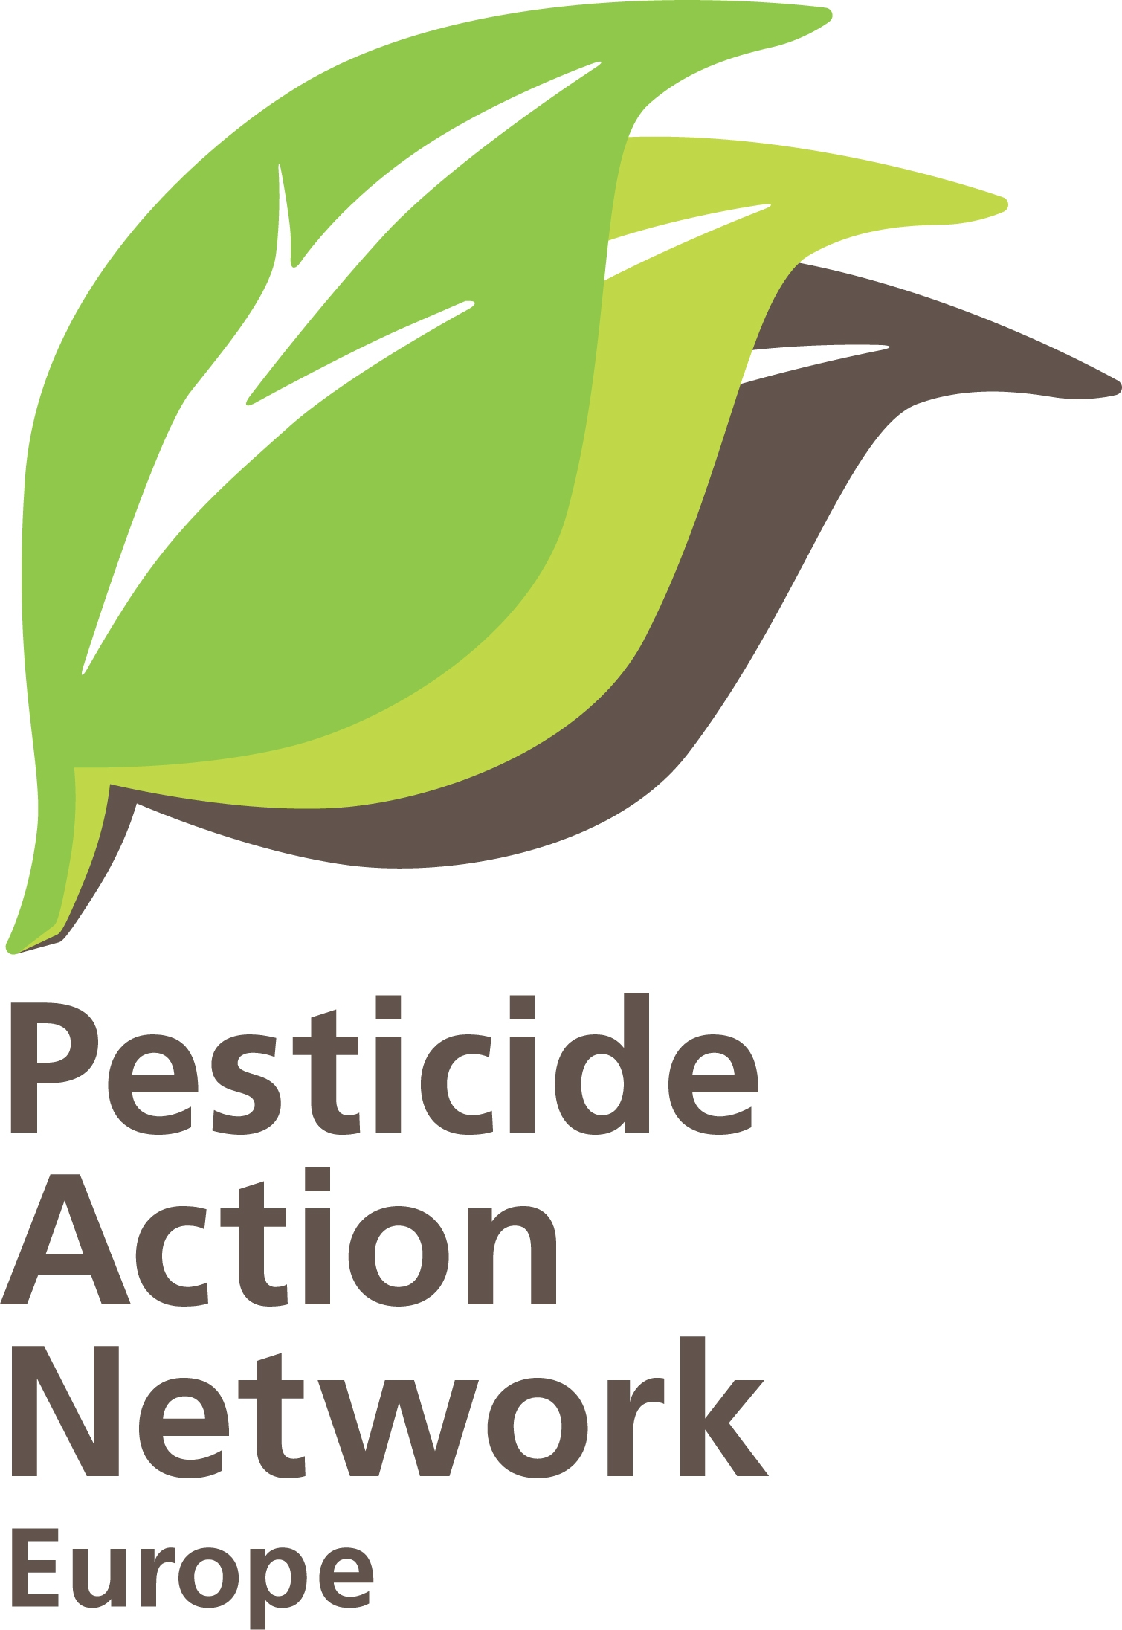 | PAN-Europe commenting guidances on zonal authorisation and mutual recognition.  Brussels, 25rd of August 2010.  Hans Muilerman.

PAN-Europe, some remarks on Guidance document on renewal, withdrawal and amendment of authorization under Regulation (EC) No 1107/2009 and on the Guidance document on zonal evaluation and mutual recognition under Regulation 1107/2009 .

Entering a new era on authorization under 1107/2009 doesn’t in our view mean just implementing a set of new rules, but first and for all modernizing the authorization in compliance with feelings of society as expressed by Parliament and Council as well as a new attitude in decision-making. We challenge Commission and Member States to start with adopting the following principles: openness and transparency, balanced operating and fairness, and as much distance to applicants as to the society as a whole in these guidances as well as others to come.

On transparency and an open decision process PAN would welcome the complete decision process to be put on the internet, the application, the reaction of the ZRMS, the reaction of other MS, etc. Also NGO’s like PAN should get the possibility of commenting the decision process at any stage. In every zone a database and the decision process of a product should be made transparent.

On a balanced approach and fairness, Commission and the ZRMS should play fully and without any restriction their role as independent government body. This means applicant to deliver the required information but in no way be involved in risk assessment and management or given the opportunity to propose ways of risk assessment, let alone risk management. Commission and ZRMS should do their own independent risk assessment and management based on independent science and the precautionary principle, and only present the draft-decision at the same time to applicants and other stakeholders. In the scheme in the Appendix time should be reserved for stakeholders (at the same moment as for applicants) to comment. Any sign of ‘dealing behind closed doors’ (see document “issues to resolve with applicant”) should be prevented.
In the Zonal Steering Committee NGO’s like PAN should be invited as an observer to get to a fair balance on information between stakeholders.

Further to this we ask you to make a provision to give all stakeholders the right to challenge the decision made by the ZRMS, if needed also in administrative court

Also because of the new era on authorization (art. 43.2), information of applicant should give a far better insight in the effects of the products proposed. We propose to demand at least:
- a personal (general manager and Board) signed letter based on Art. 56 stating that no information on the product is known to the company and involved company officers on any negative effect of the substance, metabolite and/or co-formulant beyond the information supplied in the application;
- a full overview of all scientific peer-reviewed open literature showing any and all negative effects of the product or substance on man or the environment.
- a complete overview of new endpoints of negative effects of substance/product (not assessed in previous authorization) as shown in scientific peer-reviewed open literature, including all available NOEC’s;
- a complete overview of epidemiology studies done in literature where substance, metabolite or co-formulants where links are shown or postulated with negative effects on man
- all monitoring data in Europe in (ground)water, tissue, air and soil showing residues of the product or substances in the product, highlighting all exceedances of (national) standards
- information on illegal use of the product or substances of the product
- full information of residues in food (national analysis and market analysis)
- to indicate if the product can be part of IPM in the specified product and to what extent can be substituted by non-chemical methods and practices
- information on other pesticides residues and residues of chemicals where man and the environment are exposed to with potential cumulative effects
- to verify if GLP in the field tests is based on IPM (if the authorization extends beyond 2014).

Being strong on deadlines seems to us also a key element in decision-making. It should be made clear to the applicants that ANY missing element of the data requirements and ANY change in data delivery of the official list, should automatically end up in a refusal of the application AND withdrawal of the actual authorization. Commission and MS should not fall in the trap of reinterpretating Commission data requirements and of sending alternative data sets.

On the zonal system the risk of applicants ‘shopping’ should be addressed in these guidances. It will be known soon (or may-be already now) that an authorization will be obtained more easily in one country than another. This might sometimes be due to a more industry-friendly attitude, but also to having a low capacity and expertise being no match to the resources an applicant can put in the arena. Therefore some kind of “quality control” is needed. Either a bigger institute “looks over the shoulder’ or difficult issues discussed in a wider MS-forum. The statement in the guidance “MS not to re-evaluate” the work of the ZRMS doesn’t sound as a good idea.

The risk envelope also doesn’t sound as a good idea. We can understand all involved want to reduce the workload and stimulate simplicity, but this shouldn’t be done if unknown health and environment issues are involved. The Regulation is based on the precautionary principle and this means in our view all risks to be assessed. In theory you could say to limit to worst-case situations but only if you can guarantee these cases are really worst-case. And if you didn’t assess all cases, you simply don’t know what worst-case is. Plants have different metabolisms of which we have only limited information (see pesticides exposure on bees by pollen), plants have different leaf and root systems, plants live in symbiosis with fungi, and soil and water conditions matter very much. So the good idea to limit work ends in providing another bypass for the applicant which no MS can really evaluate. We therefore ask you to abandon the idea of ‘risk envelope’.

Finally risk mitigation is sometimes used in the right way (buffer zones) but also in incorrect ways (on label: harmful for non-target organisms). Products which do not meet standards in the Regulation could be still authorized incorrectly. This misuse should be put to an end. We propose to spend some text in the guidance on risk mitigation and ensure risk mitigation is only allowed in case the provision is practically achievable, controlled independently and reliably enforced.

